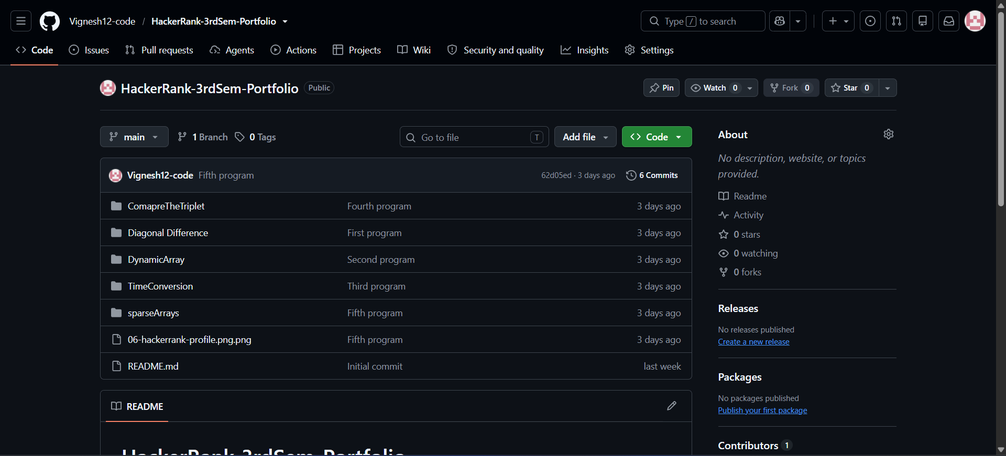
Github Repository Link: https://github.com/Vignesh12-code/HackerRank-3rdSem-Portfolio
Diagonal Difference:
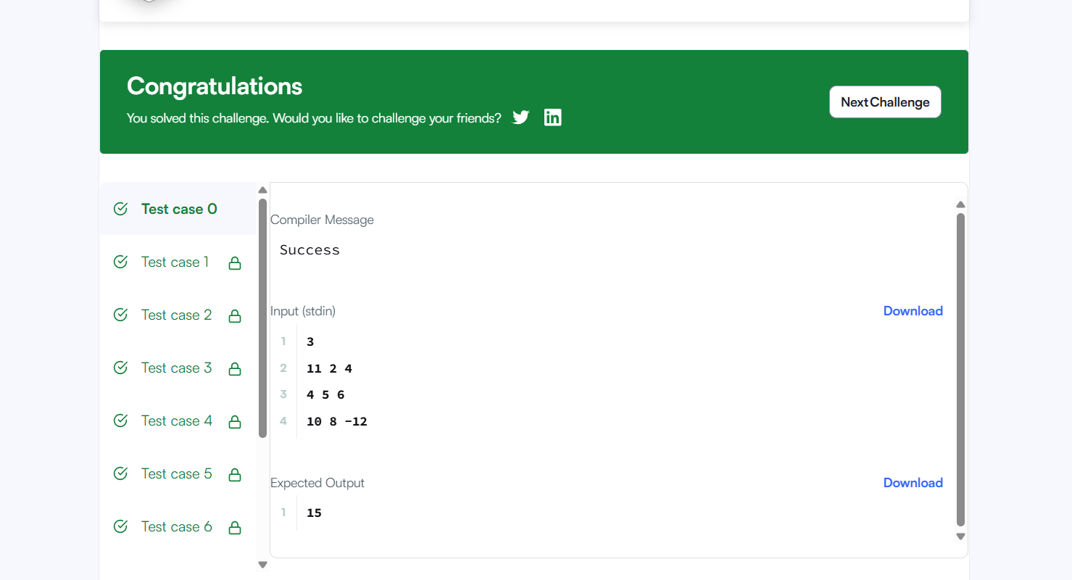

Dynamic Array:
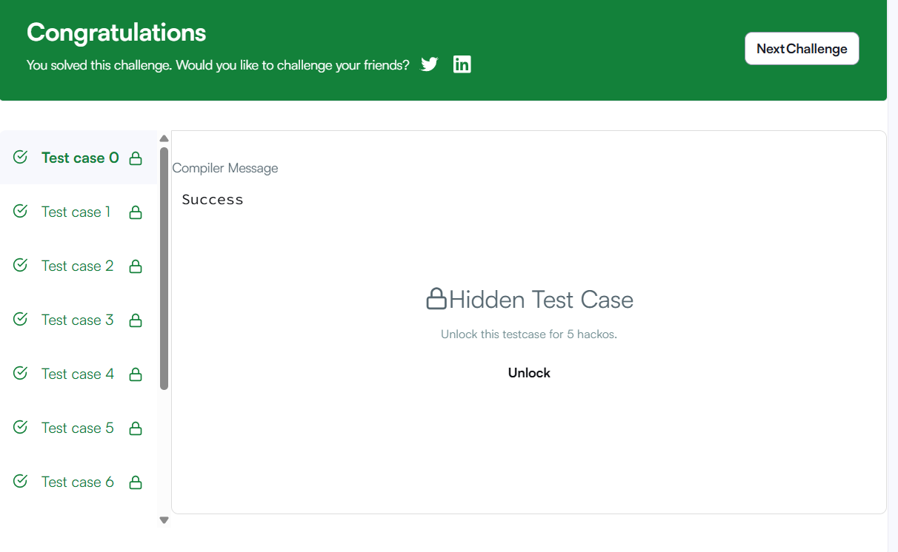
Time Conversion:
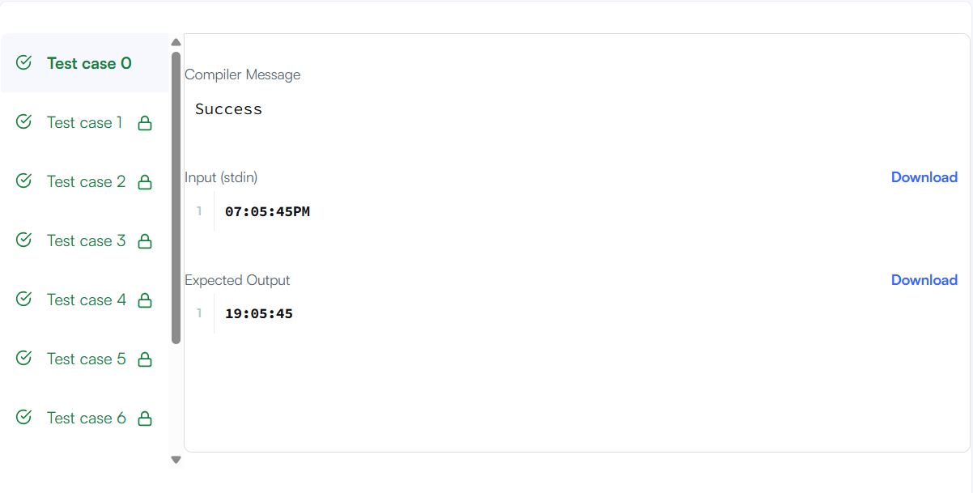

Compare the Triplets:
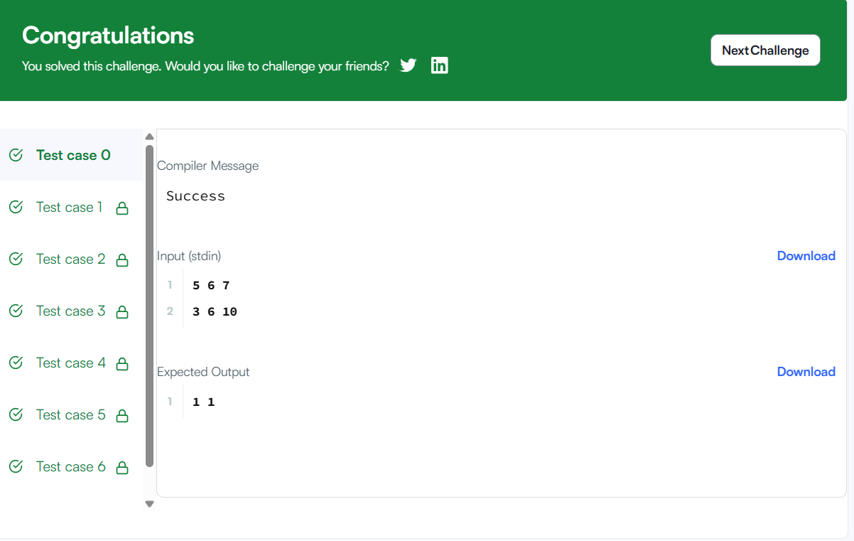

Sparse Array:
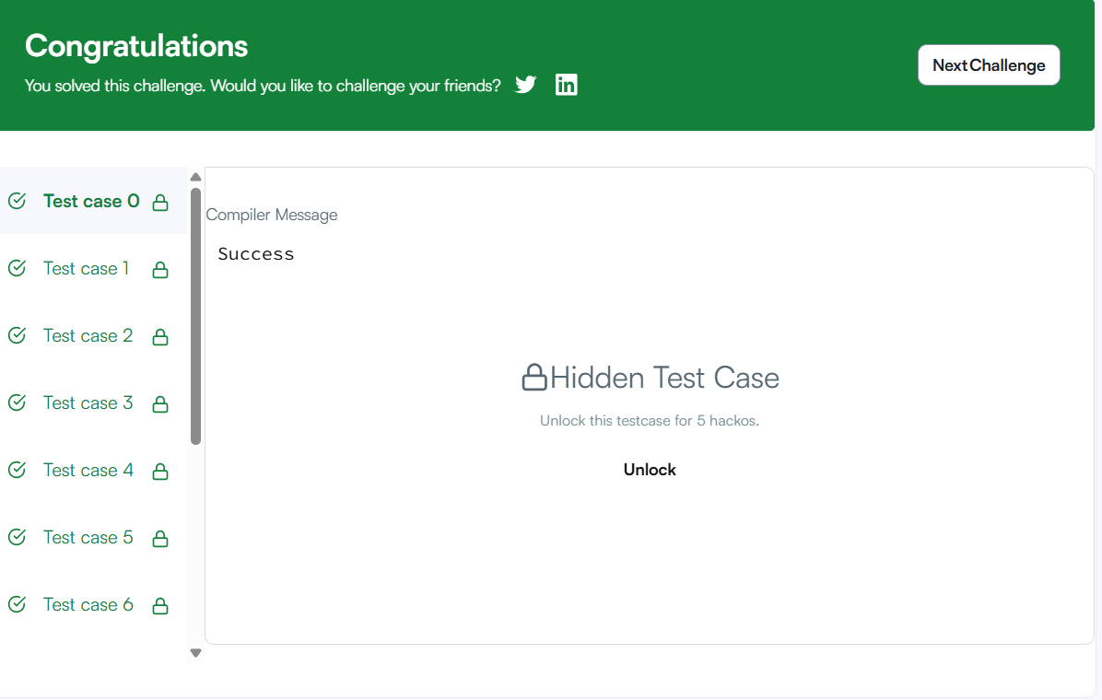
Hacker Rank Profile Screenshot:
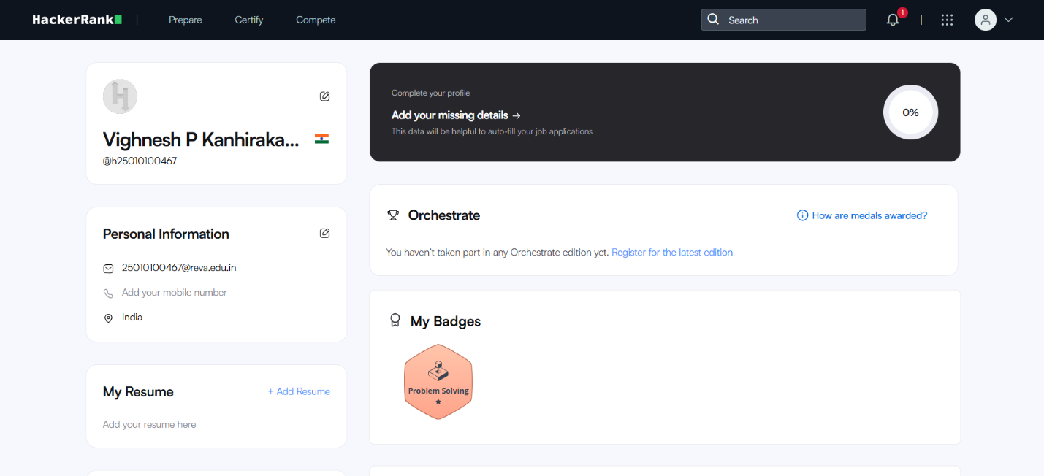
Hackerrank Profile link: https://www.hackerrank.com/profile/h25010100467

